Title
First Name Last Name¹, First Name Last Name¹, First Name Last Name²,…
¹ company/organization, address, city, country, e-mail address
² company/organization, address, city, country, e-mail address
Abstract. Body of abstract. Abstract must contain up to 200 words.
Key words: Paper key words in alphabetic order

Heading 1st order
Body text. Maximum number of pages (including abstract and references) is 10. Only cited titles are allowed to be listed in reference list, and in reference list should be only in text cited titles. Example of citation for one author of title [Paar 2006], for two authors of title [Benčić & Novaković 2005], for tree or more authors of title [Marendić et al. 2013]. It is possible to refer to internet page [URL 1].
It is necessary to refer in text to all inserted figures and tables. Tables and figures needs to be numerated with number of main chapter (1st order heading) and number of figure/table within that chapter. All tables needs to be numerated and have description above the table [table 1.1].
Table 1.1 Description of table
Text in table
A | 1 | 2
B | 3 | 4
C | 5 | 6

Tables can be up to 125 mm wide [table 1.2].

Heading 2nd order
Body text.
Table 1.2 Table with maximum width
Text in table
A | 1 | 2
B | 3 | 4
C | 5 | 6

Body text.

Heading 3rd order
Body text.
Body text of next paragraph.

Heading 1st order
Body text.

Heading 1st order
Figures can be up to 125 mm wide. All figures needs to be numerated and have description below the figure [figure 3.1]. All figures needs to be send, in .jpg or .png format with minimum resolution of 300 dpi, together with paper.
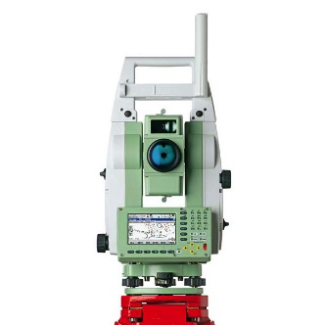
Figure 3.1 Leica TPS 1201
Equations need to be written using “MS Word Equation editor”. All symbols and number in equation should be written with font “CMU Serif”, size 10 pt. All equations need to be numerated. If necessary, equations can be cited, for example “see equation (1)”. It is necessary to describe all symbols used in equations. Example of equation:
$x=\frac{-b±\sqrt{b^{2}-4ac}}{2a}$ (1)
Body text.

Conclusion
Every article needs to finish with the chapter “Conclusion”.

References
Benčić, D.; Novaković, G. (2005). Meaning and Comparison Analysis of the Terms Mean Square Error and Standard Deviation, Zagreb: Geodetski list, 59 (82), pp. 31-44, No. 1, 2005.
Janković, M. (1981). Inženjerska geodezija III. Sveučilišna naklada Liber, Zagreb.
Marendić, A.; Kapović, Z.; Paar, R. (2013). Possibilities of Surveying Instruments in Determination of Buildings’ Dynamic Displacements, Zagreb: Geodetski list, 67 (90), pp. 175-190, No. 3, 2013.
Paar, R., (2006). Establishment of geodetic basis for special purposes, Master thesis, University of Zagreb, Faculty of Geodesy, Zagreb, 2006.
URL 1: Faculty of Geodesy, University of Zagreb, www.geof.unizg.hr, (12.01.2016.)
URL 2: …

